Problem Statement or Requirement: A requirement from the Hospital, Management asked us to create a predictive model which will predict the Chronic Kidney Disease (CKD) based on the several parameters. The Client has provided the dataset of the same.
1.) Identify your problem statement: A hospital management team wants to develop a predictive model that can identify/predict whether a patient is likely to have Chronic Kidney Disease (CKD) based on various clinical parameters in the CKD dataset.
- Stage 1: Machine Learning – Predict the presence or absence of CKD for new patients
- Stage 2: This is a Supervised Machine Learning problem because the dataset contains both:
  - Input Features (Independent Variables) – Patient clinical parameters.
  - Output Variable (Dependent Variable) – CKD classification (Yes/No).
  - The model learns from historical data where the correct diagnosis is already known and then predicts the diagnosis for unseen patient records.
- Stage3: Classification – Since the output contains only two possible classes, this is a Binary Classification problem.
2.) Tell basic info about the dataset (Total number of rows, columns)
- Total Columns: 25
- Input Variables: 24
- Output Variable: 1
3.) Mention the pre-processing method if you’re doing any (like converting string to number – nominal data)
Used get_dummies to convert the following categorical columns into numbers. All are nominal data
- sg
- rbc
- pc
- pcc
- ba
- htn
- dm
- cad
- appet
- pe
- ane
- classification
4.) Develop a good model with good evaluation metric. You can use any machine learning algorithm; you can create many models. Finally, you have to come up with final model.
The Logistic Regression algorithm has come up with 100% accuracy.
precision recall f1-score support
0 1.00 1.00 1.00 51
1 1.00 1.00 1.00 82

Accuracy 1.00 133
macro avg 1.00 1.00 1.00 133
weighted avg 1.00 1.00 1.00 133

5.) All the research values of each algorithm should be documented. (You can make tabulation or screenshot of the results.)
1. SVM:
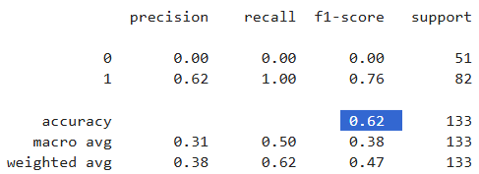
2. Random Forest
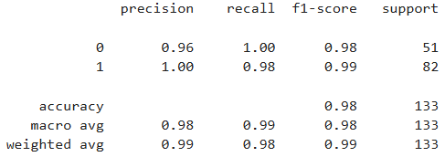
3. Decision Tree
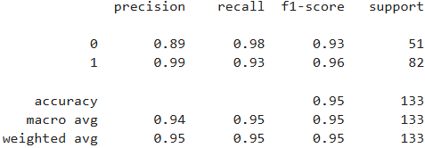
4. Logistic Regression
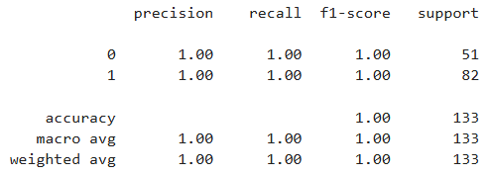
5. KNN
+-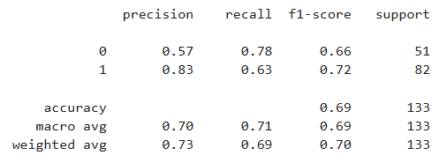
6. Navies Bayes
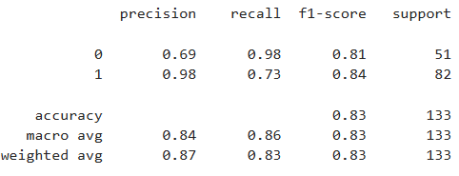
Model Performance Comparison
Algorithm | Accuracy | Class 0 Precision | Class 0 Recall | Class 0 F1 | Class 1 Precision | Class 1 Recall | Class 1 F1 | Macro Avg (P/R/F1) | Weighted Avg (P/R/F1) | Interpretation
Logistic Regression | 1.00 (100%) | 1.00 | 1.00 | 1.00 | 1.00 | 1.00 | 1.00 | 1.00 / 1.00 / 1.00 | 1.00 / 1.00 / 1.00 | Perfect classification of both CKD and non-CKD patients. No false positives or false negatives. Best performing model.
Random Forest | 0.98 (98%) | 0.96 | 1.00 | 0.98 | 1.00 | 0.98 | 0.99 | 0.98 / 0.99 / 0.98 | 0.99 / 0.98 / 0.99 | Excellent performance with very high precision and recall.
Decision Tree | 0.95 (95%) | 0.89 | 0.98 | 0.93 | 0.99 | 0.93 | 0.96 | 0.94 / 0.95 / 0.95 | 0.95 / 0.95 / 0.95 | Very good performance. Correctly classified most CKD patients
Naïve Bayes | 0.83 (83%) | 0.69 | 0.98 | 0.81 | 0.98 | 0.73 | 0.84 | 0.84/0.86/0.83 | 0.87/0.83/0.83 | Good performance. High recall for Class 0 but lower precision
K-Nearest Neighbors (KNN) | 0.69 (69%) | 0.57 | 0.78 | 0.66 | 0.83 | 0.63 | 0.72 | 0.70 / 0.71 / 0.69 | 0.73 / 0.69 / 0.70 | Good predictive performance with balanced metrics. Performance depends on the value of K and distance calculation.
Support Vector Machine (SVM) | 0.62 (62%) | 0.00 | 0.00 | 0.00 | 0.62 | 1.00 | 0.76 | 0.31 / 0.50 / 0.38 | 0.38 / 0.62 / 0.47 | Poor performance. Failed to correctly identify Class 0, making it unsuitable for CKD prediction on this dataset.

6.) Mention your final model, justify why u have chosen the same. Note: Mentioned points are necessary, kindly mail your document as well as .ipynb (code file) with respective name.
Logistic Regression is the final model because it achieved 100% Accuracy, Precision, Recall, and F1-Score, indicating perfect classification of CKD and non-CKD patients in the test dataset.
The reasons for selecting Logistic Regression are:
- Highest Accuracy: 100% accuracy, correctly classifying all patients in the test dataset.
- Perfect Precision: Precision of 1.00 indicates patients were correctly were classified correctly
- Perfect Recall: Recall of 1.00 indicates the model successfully identified all actual CKD and non-CKD patients
- Highest F1-Score: An F1-score of 1.00 shows overall performance of CKD and non-CKD classified is accurate.
- Confusion Matrix: The confusion matrix showed zero misclassified observations.
